**Plagiarism Statement -** Title of Report, Team Members Names, ID Numbers, Date etc.

I confirm that this assignment is my own work, no part of it has copied from any other person's work (published or unpublished), and any text that has been paraphrased has been cited in the body of the document with the full details of the original work included in the reference list.

I also confirm that I have read the guidance provided at:

<http://www.hope.ac.uk/gateway/supportandwellbeing/studentadministration/understandingyourdegree/>

I also confirm that I understand the consequences of academic misconduct and that it may result in termination of my studies at Liverpool Hope University.

|  |  |  |
| --- | --- | --- |
| Name | Sign | Date |
| Callum Owen-Bridge 15002504 |  | 19/02/2017 |

*Note: Add additional lines as necessary. If you do not have an electronic signature you can create one by taking a picture of your signature*

Health Monitor

By: Callum Owen-Bridge 15002504

Index

|  |  |
| --- | --- |
| Chapter | Page |
| 1.0 eHealth Device | 3 |
| 2.0 Materials | 3 |
| 3.0 Method | 4 |
| 4.0 Discussion | 8 |
| 5.0 Conclusion | 10 |
| 6.0 References | 10 |

A health device which can monitor and feedback human body signals.

**Problem:** To devise a monitor which can collect and record multiple human body signals, for people with ongoing health problems or who require this monitor due to working conditions.

## 1.0 eHealth Device

This device is very useful for people with ongoing health problems or who want to monitor their fitness or monitor a close relative such as an elderly person or want to use this device due to their working conditions; such as working in a mine. The device created is a prototype; which has components designed by cooking hacks (Cooking-hacks.com, 2017). The prototype is portable and can connect to a computer via Bluetooth or by a USB cable. The battery of the device will last up to 60 hours of continuous use, as the battery pack holds twelve AA batteries and the Arduino consumes around 500mA.

The current state of the prototype restricts its usage due to its cumbersome weight, size and the type of components implemented.

The prototype has an array of sensors which monitor the user’s body temperature, heart rate, air flow, blood oxygen saturation, blood glucose levels and galvanic response (how much the user is perspiring). The prototype collects data from these sensors and sends it to software on a computer via Bluetooth, where the data is stored to a file and displayed in graphical form.

The final device, will be more compact and will have forms where it can be either incorporated into clothing or worn as an external device; which could be used by hospitals to monitor patients or by medical health professionals.

## 2.0 Materials

Hardware:

* Bluetooth shield (Encryption type AES, Version 3.0), shown in figure 1
* eHealth shield v2.0, shown in figure 2
* Arduino UNO, shown in figure 3
* Battery pack, shown in figure 4

Software:

* Arduino integrated development environment (IDE), to code the Arduino, (Zambetti et al., 2017).
* 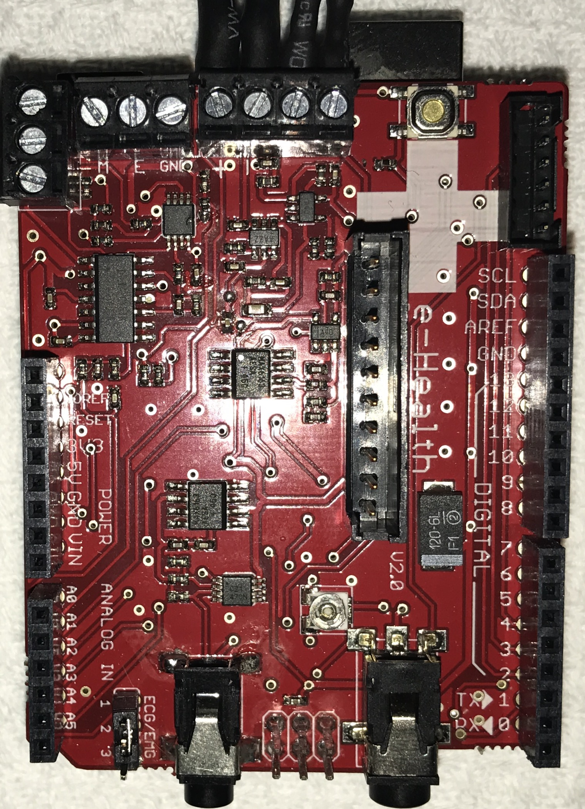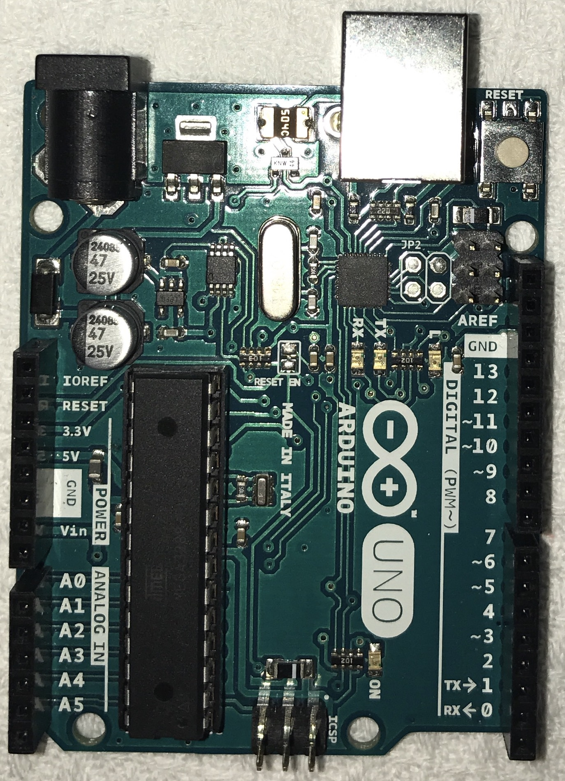Processing, to read the data from the Arduino and provide a graphical representation of the data, (Reas and Fry, 2017).

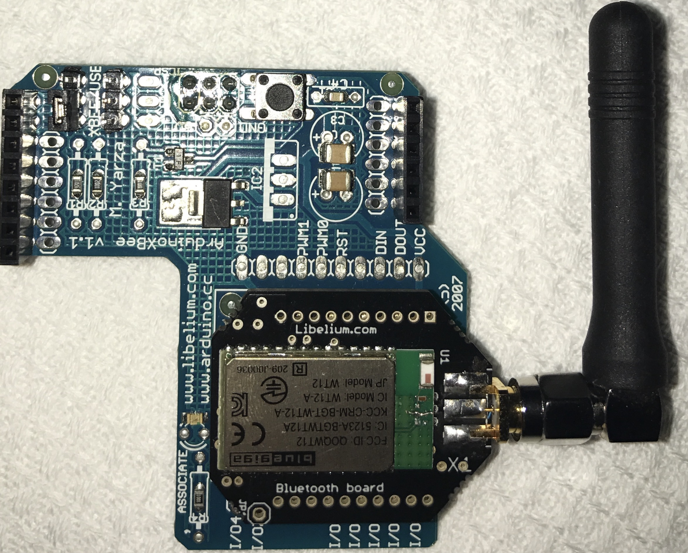

Figure 1 The Bluetooth shield

Figure 3 Arduino Board

Figure 2 eHealth shield

## 3.0 Method

3.1 Hardware

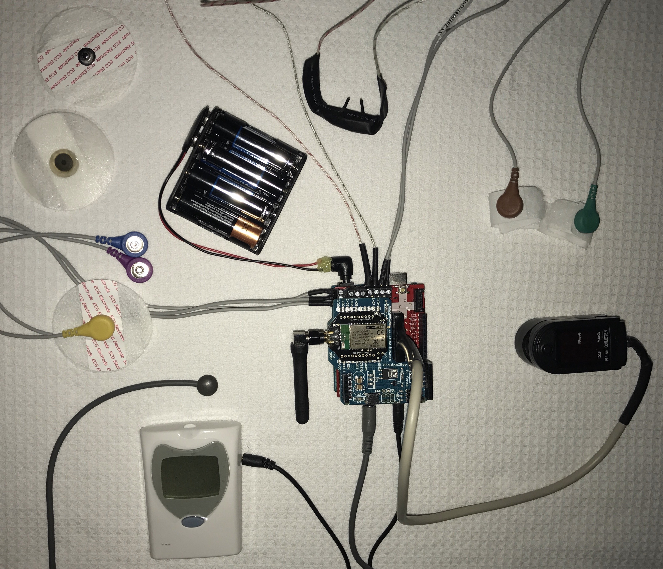

Electrode

Battery Pack

ECG/EMG

Thermometer

Glucometer

Monitor

Pulse-oximeter

Galvanic Skin Response

Air flow

Figure 4 the health monitor

The diagram in figure 4 shows the components of the eHealth monitor. Each of these components are required for the monitor to show the wellbeing of the user. The dimensions of the health monitor are 11 cm (length) by 8.5 cm (width) by 4.5cm (depth) and weighs around 503 grams with the battery back and 250 grams without the battery pack.

The health monitor created uses six sensors:

* Body temperature: a thermistor, which records the temperature of the body. This sensor is required because if the body temperature changes it could be a sign of illness; for example, hypothermia (less than 35 °C) is caused by a reduced temperature (Nhs.uk, 2017) and high temperature (more than 38 °C) is shown with a rise in temperature, (Hereforyouhampshire.nhs.uk, 2017). This sensor has a maximum deviation of 0.1 and measures to 1 decimal place, therefore this sensor is accurate and precise. This sensor can be used on skin and so can be placed at axillary points of the body (armpits) or placed on the temporal artery (located on the sides of the head), (Cooking-hacks.com, 2017).
* Electrocardiogram(ECG): This is used to monitor the heart’s functionality. The ECG uses three electrodes. The electrode pads are connected to each sensor and placed on the user shown in figure 5. The ECG can be used with the user laying down or sitting on a chair. The positive electrode is yellow, neutral is purple and negative is blue, (Cooking-hacks.com, 2017).

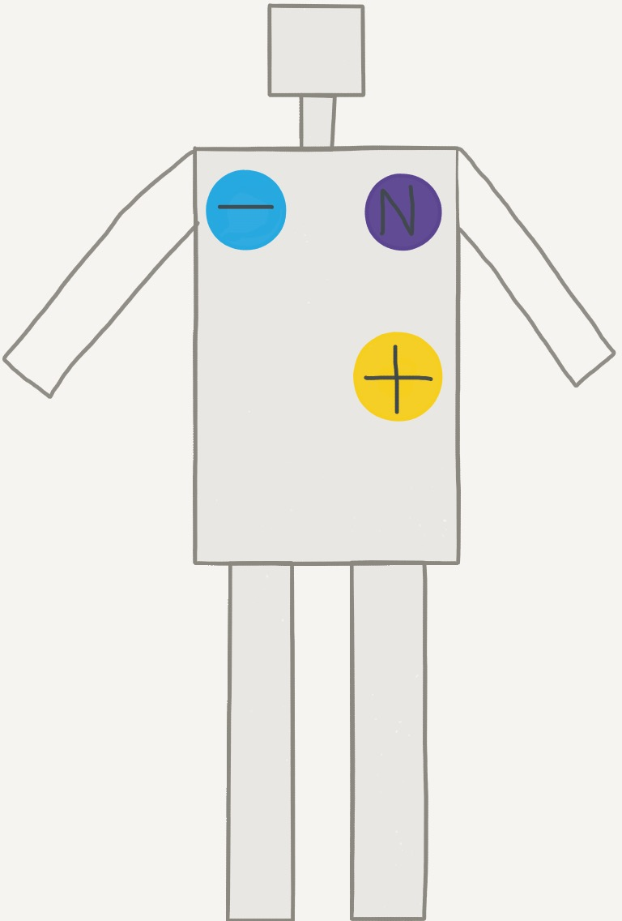

Figure 5 An am with ECG pads

* Electromyography (EMG): measures the electrical pulses generated by muscles, when the muscle cells are electrically activated, such as a change in position. This sensor can help to identify any abnormalities in the activation levels, (Neuromuscular disease, assessing lower back pain, motor control). This uses the same sensors used for the ECG, to use the sensors the jumper shown in figure 6 must be set into EMG. The blue connector of the EMG attaches to close to the elbow area using a pre-gelled electrode. The purple connector attaches to the top of the forearm near the inner elbow and the yellow connector attaches to the top of the mid-upper arm. These positions are shown in figure 7, (Cooking-hacks.com, 2017).

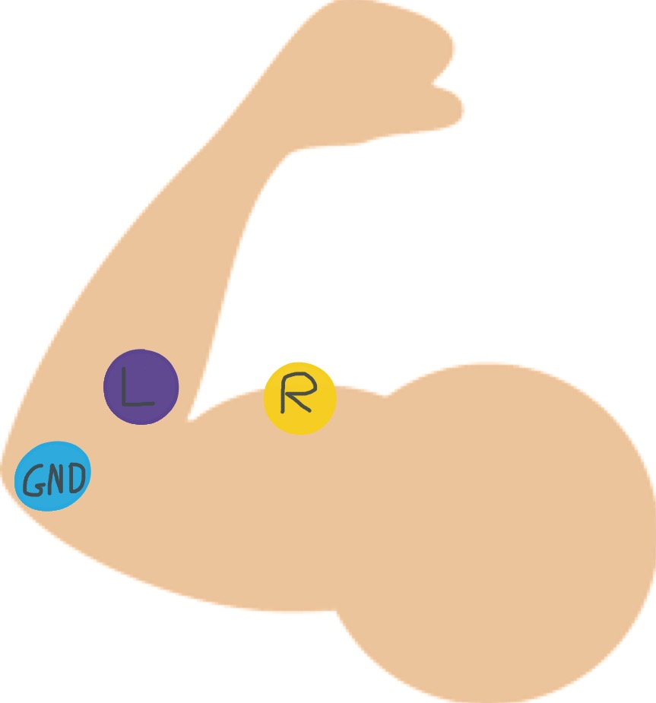

Figure 7 A body with ECG pads



Figure 6 jumper currently set to ECG

* Airflow: This is placed on the upper lip, with the cables going over the ears and the two prong like objects are placed below the nostrils. The prongs measure the change in temperature as the user breathes in and out through the nose. This sensor can help people who have respiratory problems (Cooking-hacks.com, 2017).
* Galvanic Skin Response (GSR): “a method of measuring the electrical conductance of the skin, which varies with its moisture”, (Cooking-hacks.com, 2017). This sensor can show an indication of psychological or physiological responses due to the sweat glands being controlled by the sympathetic nervous system. The skin resistance is measured, low resistance indicates the user is sweating whereas a higher resistance indicates the user has drier or dry skin. This sensor is often used in polygraphs. (Cooking-hacks.com, 2017).
* Pulse-oximeter: this is placed on the index finger. The pulse-oximeter displays the oxygen saturation of the blood and the beats per minute(BPM). The device uses two different light wavelengths, red light and infrared light, to measure saturation levels of deoxyhaemoglobin and haemoglobin in the blood stream. (Cooking-hacks.com, 2017).
* Glucometer: measures blood sugar levels. The testing strip is inserted into the monitor. A needle is used to extract a small drop of blood from the user’s finger. The drop of the user’s blood is placed onto a testing strip. The monitor will then display the blood glucose level in mmol/L. (Cooking-hacks.com, 2017).

The Bluetooth shield uses encryption to send and receive signals, “the process of scrambling a message so that only the intended recipient can read it”, (Singh and Supriya, 2013). Therefore, keeping the data private so only healthcare professionals and the user can view the data. The encryption type is AES (Advanced Encryption Standard). The Bluetooth shield has Bluetooth version 3.0 this makes it power efficient as it consumes power depending on the distance between it and the connected device, and the data transfer. The range of the Bluetooth is eighteen metres; however, walls can interfere with the signal.

The battery pack holds twelve non-rechargeable AA batteries, as shown in figure 4. This was soldered to a power jack that fits the Arduino board. The battery pack provides a combined capacity of at least 30,000mAh at 12 volts. This will allow the device to run for up to 60 hours continuously.

The Arduino IDE is used to create code to collect data and communicate with an application. The functions used are provided by the eHealth library; which must be installed into the Arduino IDE this is described on the Cooking Hacks library where the eHealth library download can also be found, (Cooking-hacks.com, 2017). The pulse-oximeter, requires a delay due to the how it gathers and sends data, shown in figure 8. The code required to output the sensor data to the serial port was then created and placed into a void loop as shown in figure 9. This is required so that the application can receive the data.

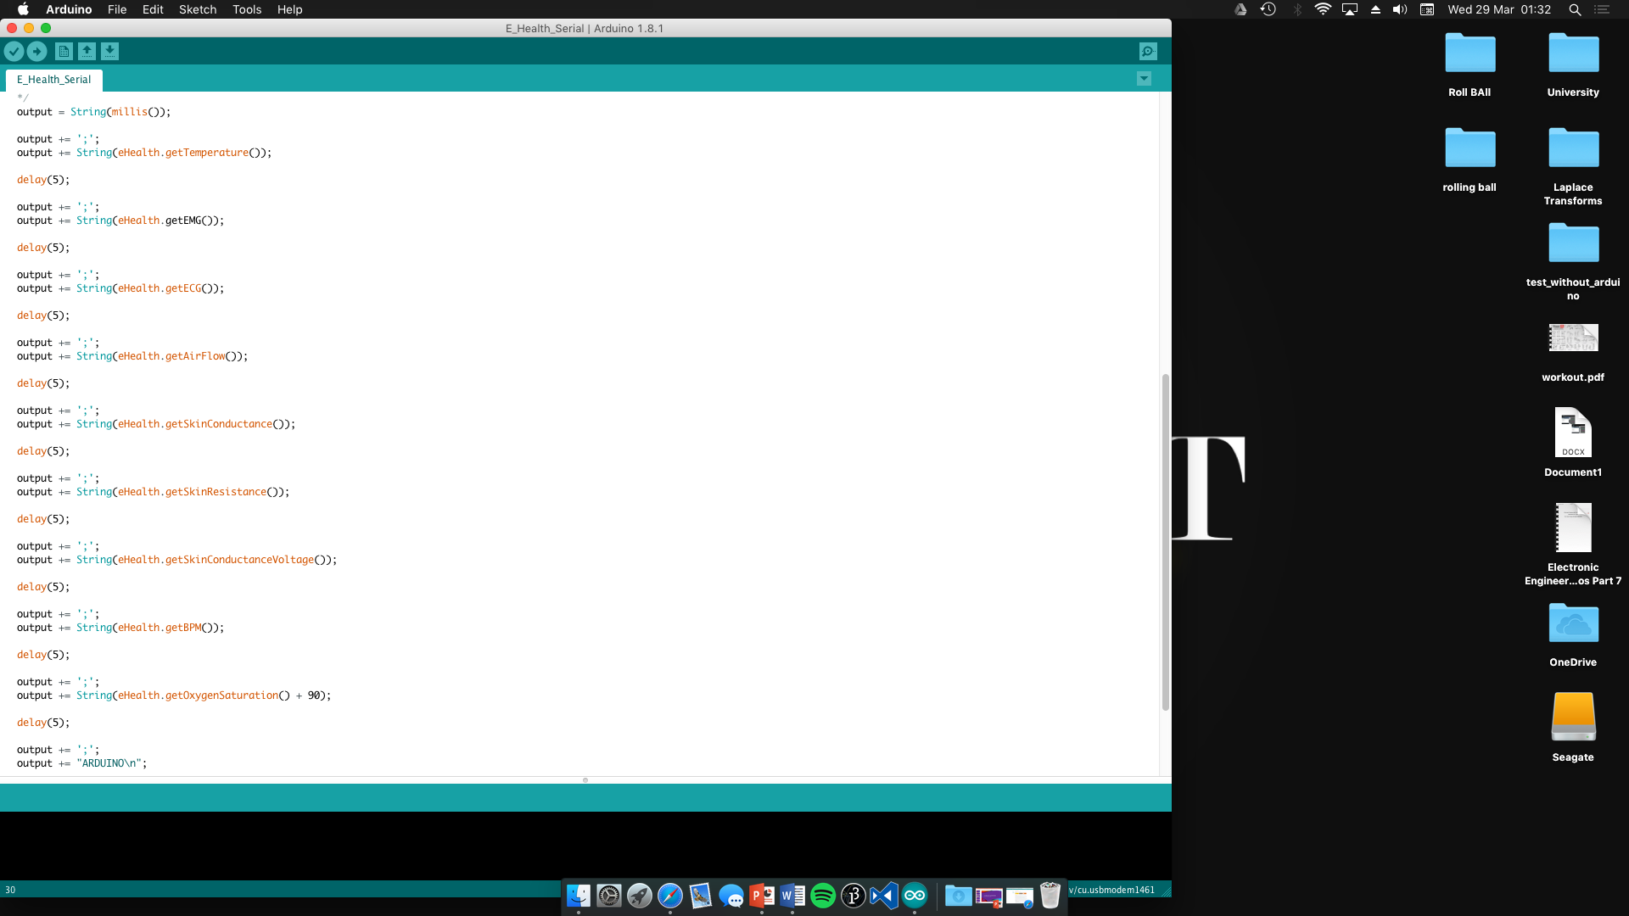

Figure 9 serial output code

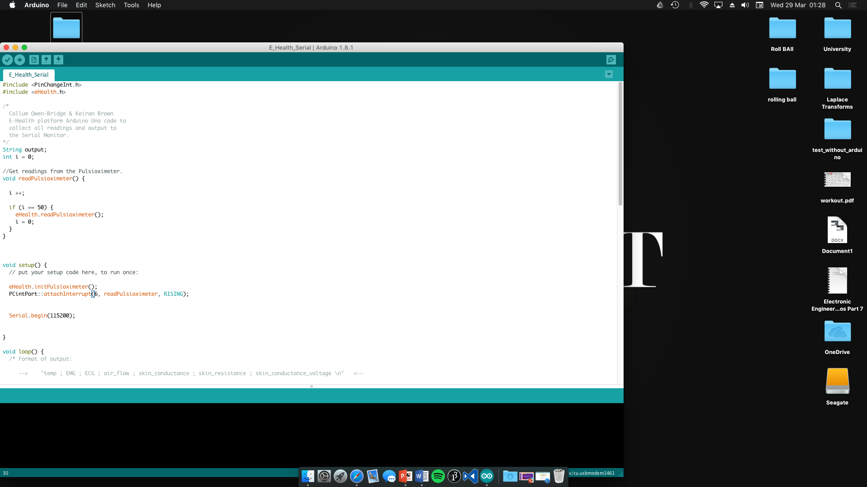

Figure 8 pulse-oximeter delay code

The Bluetooth shield, shown in figure 1, was added to the Arduino board to test its wireless functionality, two jumpers shown in figure 5, were then put into XBEE mode allowing the Arduino to communicate via Bluetooth and therefore become wireless. To communicate with the Arduino via the USB cable set the jumpers to USB. Once the Arduino serial monitor was receiving data via Bluetooth, the shield was removed and the eHealth shield, shown in figure 2, was then added to the Arduino board. This shield is used to connect all the sensors to the Arduino board. One sensor was connected, such as the temperature sensor; to test the Arduino code. If the correct data was shown in the Arduino serial monitor for that sensor then each sensor was tested individually; this helped to identify issues in the code and any possible hardware faults. During testing, the body position sensor had a fault and so it had to be omitted from the project. Once all issues were resolved, the code was uploaded to the Arduino board.

The Bluetooth shield and battery pack was added to the Arduino board; this allows the health monitor to be more portable.

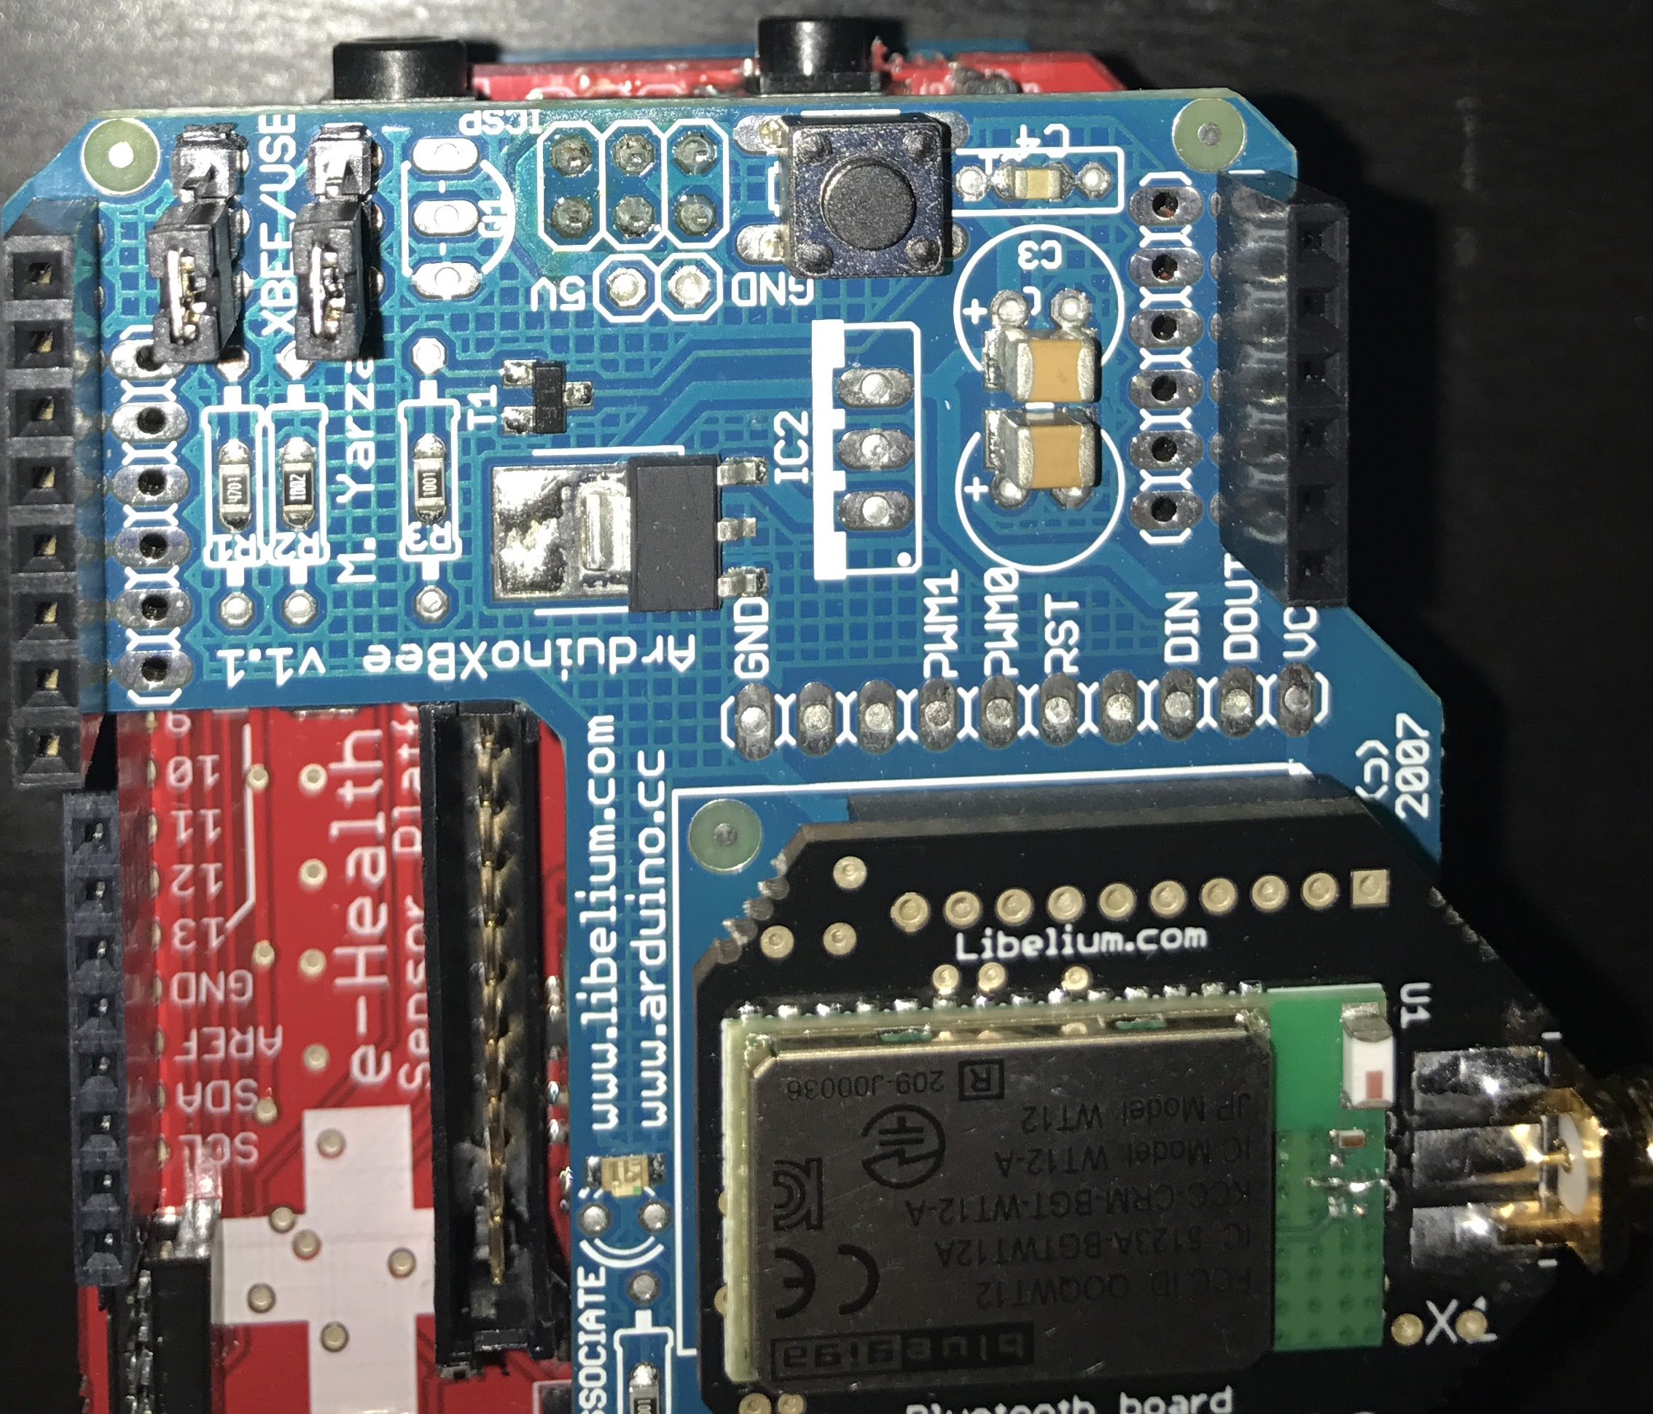

Figure 10 showing jumper positions

3.2 Software

Processing is used to create a graphical user interface. A function was created to perform a handshake, this is where the Arduino sends a string which processing searches for in the computers serial ports, shown in appendix. Once found processing will use that serial port to communicate with the health monitor. Once the program has found the serial port with the Arduino, it reads the output stream of the Arduino and displays the data in a line graph form as well as writing the data into a text file. Different colours are used for the line graphs to distinguish between the different graphs. Each sensor has a graph, as shown in figure 11, their values are displayed above the graph.

Once the program starts the user will be prompted to enter the name of the file. Once entered the interface will appear showing all the data values with corresponding graphs. If the user has finished, the data can be saved by pressing any key on the keyboard. The program will save the data into the named file and close. The file type is a .txt, as shown in figure 12.

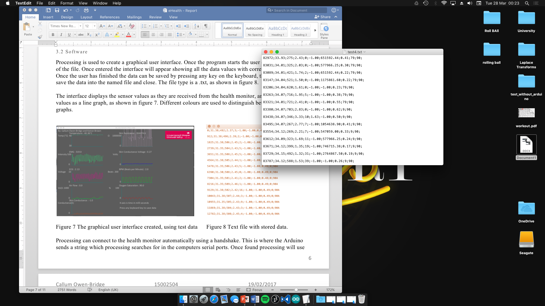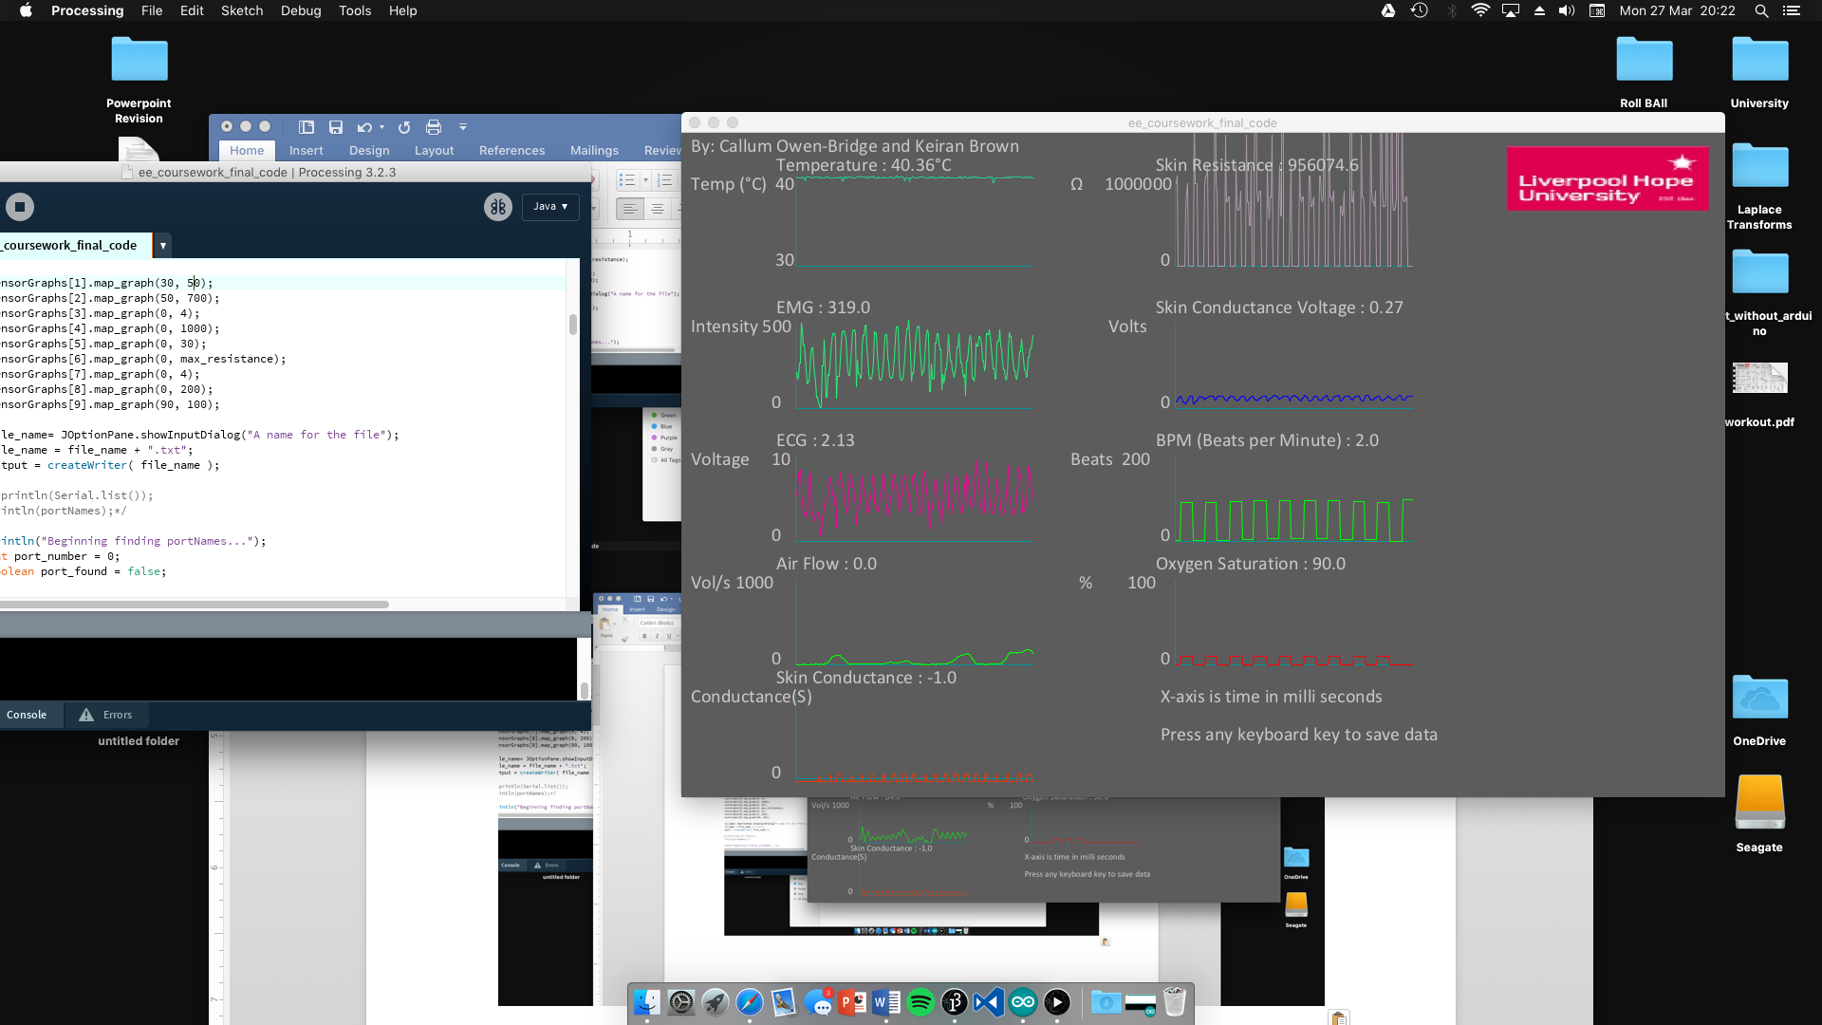

Figure 11 The graphical user interface created, using test data Figure 12 Text file with stored data.

## 4.0 Discussion

4.1 What is a health monitor?

A health monitor is a device containing an array of sensors to monitor the human body. This allows the device, healthcare professional or user to monitor the body for any abnormalities, such as an increase in body temperature or high heart rate.

Health monitors can be used by anyone and can be modified to certain situations, for example for the elderly may not require a GSR or people with ongoing health conditions such as diabetes would require a glucometer. Someone who works in high altitudes will require a sensor such as a pulse-oximeter as the oxygen levels reduce as altitudes increase. Aqueveque, Gutierrez and Saavedra have created a more compact design of a health monitor but in a t-shirt form. “The sensors are incorporated into a microfiber t-shirt, the circuit connection is made by a conductive wire.” (Aqueveque, Gutierrez and Saavedra, 2016). This t-shirt is a much better design, more compact and is less cumbersome than the prototype and so is more practical for miners.

A place where this device could be used is emphasised by the Government of Holland, as in Holland they are encouraging the use of eHealth. eHealth is where a patient’s health data is kept digital and contains all their medical records and only they can access their information, (Government.nl, 2017). The one of the goals the government would like to achieve is health monitoring, where “chronically ill people and vulnerable elderly people should be able to monitor certain aspects of their own health and share the data with their health provider. This would include things like blood pressure and cholesterol levels.”, (Government.nl, 2017). The health monitor would be very useful for this situation as it is able to monitor the vital signs of the human body and can display them in clear graphical form as well as save the data to a file.

Vital signs of a patient that should be monitored by medical professionals are:

* Body temperature
* Pulse rate
* Respiration rate
* Blood pressure

“Vital signs monitoring is an important nursing assessment.”, (Mok, Wang and Liaw, 2015). These vital signs must be monitored as this can show if the patient is deteriorating. The prototype can measure three of these vital signs; body temperature via the temperature sensor, pulse rate via the pulse-oximeter and respiration rate by calculating how many breaths are taken per minute using the air flow sensor. A blood pressure monitor can be added to the prototype, to be able to record the final vital sign.

4.2 Results

Overall, the health monitor works well. The device can monitor the user efficiently and safely. The data that is collected is continuous and does not contain anomalies. The Bluetooth connection is reliable, very efficient and encrypted, allowing the device to become portable and securely. Most of the sensors work very well and all work together. The sensors are accurate; however, they do not have any medical certification and so the prototype cannot be used to indicate any medical health conditions. The battery works very well with the device and last for a long period of time, making the device more portable and allowing the user to have more freedom of movement.

The application used to view and store the data works efficiently and clearly shows the data that is being collected from the monitor. The graphs shown are very clear and update in real-time, allowing the user or health care professional to clearly find any abnormalities in the health of the user. The application will work on most screen resolutions, the lowest resolution being 720p. The application stores the continuous data into a text file which could be read by a health care professional for analysis providing faster consultations. Continuous data, allows health care professionals to be more accurate in diagnosing the patient and can help the user or health care professional to distinguish between anomalies and possible illness, as the abnormality would occur more often.

Issues

The prototype created is designed for research purposes only and so is not medically tested and does not have a medical certification. When testing all the sensors that came with the kit the only sensor that was faulty was a body position sensor; the sensor would not pass any values to the Arduino board. The pulse-oximeter and glucometer require batteries to function properly which can be an issue, as the user may not be able to replace the batteries due to dexterity problems. The monitor is cumbersome and is not water resistant, so the monitor may only be used indoors and due to current weight and size is not recommended to be used continuously.

To use the EMG or ECG the sensors must be attached to the body using electrodes which may irritate the skin or detach from the user and requires the surface to be clear of hair which may be an uncomfortable process for the user to go through daily. With this health monitor the ECG and EMG cannot be used at the same time and so the cables must be connected to different ports on the device when switching between the ECG and EMG.

Some of the sensors have long cables which could cause discomfort when wearing the device, or exercising. A wireless solution would remove this issue and prevent any injuries.

The battery pack is heavy and large, which could make the monitor difficult to carry. The battery pack is currently not rechargeable therefore will require disposable batteries, this is no environmentally friendly or cost effective for the user. Due to the high voltage of the battery pack output the Arduino board’s voltage regulator produces a lot of heat over time, which could cause injuries or reduce the functionality of the device, so the monitor cannot be used for long periods of time otherwise it may become a hazard to the user.

The sensors must be calibrated to ensure the collected data is valid and is providing correct data, otherwise this could cause false diagnosis and anxiety problems for the user. The Bluetooth shield susceptible to interference such as being obstructed by walls, this could cause loss of data.

The application used to collect and display the data does not open as an ordinary application and so may not be suited for a non-technical person. The application stores the data in a basic file, but is not able to read the file if required. The file storing the data is not encrypted and so has privacy and security issues. The application only displays and stores data it is not able to send any information to a health care professional and is not capable of providing information about the collected data, such as detecting an abnormal heart rate.

4.3 Benefits

The benefits of using health monitors are:

* Data can be sent to the General Practitioner reducing the amount of appointments required and costs for monitoring equipment. This can also increase the speed of diagnosis.
* The health monitor could eventually prevent or warn impending medical incapacity. Some health monitors can compare the data collected from the user with data in a database.
* The health monitor could receive medical test results in a much faster time, therefore reducing the amount of appointments required to see a health care professional.
* The health monitor could monitor many health conditions, making it more versatile.
* Health monitors can be very portable; therefore, it can be used when exercising or daily routines.
* More cost and time effective, as the users would not have to go to appointments as often and the device is modular so, not all sensors have to be connected.
* Communication to GP; this allows a quicker consultation time and quick response if there are abnormalities found in the health data.
* The health monitor could save lives, by making the user more aware of the current body health condition for example an abnormal high heart rate.
* The health monitor can assist with medical conditions such as diabetes or cardiovascular diseases.

4.4 Concerns

The concerns of using health monitors are:

* Privacy concerns over data; such as who can view or have access to the data.
* False information could lead to anxiety and false diagnosis; if the monitor is not calibrated the data could form anomalies and provide false data, his could also lead to false diagnosis.
* If the user has many medical conditions the cost of the device can be very prohibitive; as this could require more sophisticated and expensive sensors.
* Accuracy; the device must be accurate to be able to provide advice or be used by health care professionals, such as gaining a medical certification.
* Battery power; this could be an issue with people who require many sensors as they could increase power consumption and therefore would require larger battery packs or charging the device more often.
* The battery pack can be quite cumbersome and therefore not suitable for most users.
* The battery pack must be rechargeable as replacing batteries is not cost effective and is not environmentally friendly.

## 5.0 Conclusion

To conclude, the prototype works very well and the prototype provides a solution to the problem as it provides useful data that can be used to interpret to diagnose health conditions of the body, such as low blood oxygen concentrations or a constant increase in heart rate.

The application is very useful and clearly displays the collected data, which can help health care professionals or users to keep track of their health. Although there are issues with the device and application, they can be resolved in the next prototype, such as making the health monitor more compact, enclose the device in a box to keep it protected and a more convenient battery solution.

## 5.0 References

Aqueveque, P., Gutierrez, C. and Saavedra, F. (2016). Noninvasive health condition monitoring device for workers at high altitudes conditions. [online] Available at: http://ieeexplore.ieee.org/document/7591201/?section=abstract [Accessed 29 Mar. 2017].

Cooking-hacks.com. (2017). *MySignals HW v2 - eHealth and Medical IoT Development Platform for Arduino*. [online] Available at: https://www.cooking-hacks.com/mysignals-hw-ehealth-medical-biometric-iot-platform-arduino-tutorial/ [Accessed 17 Mar. 2017].

Government.nl. (2017). *Government encouraging use of eHealth | eHealth (telehealth) | Government.nl*. [online] Available at: https://www.government.nl/topics/ehealth/contents/government-encouraging-use-of-ehealth [Accessed 29 Mar. 2017].

Hereforyouhampshire.nhs.uk. (2017). *NHS*. [online] Available at: http://hereforyouhampshire.nhs.uk/Fever.html [Accessed 28 Mar. 2017].

Mok, W., Wang, W. and Liaw, S. (2015). Vital signs monitoring to detect patient deterioration: An integrative literature review. *International Journal of Nursing Practice*, [online] 21, pp.91-98. Available at: https://www.ncbi.nlm.nih.gov/pubmed/26125576 [Accessed 29 Mar. 2017].

Nhs.uk. (2017). *Hypothermia - NHS Choices*. [online] Available at: http://www.nhs.uk/Conditions/Hypothermia/Pages/Introduction.aspx [Accessed 28 Mar. 2017].

Reas, C. and Fry, B. (2017). *Processing 3*. Processing.

Singh, G. and Supriya, S. (2013). A Study of Encryption Algorithms (RSA, DES, 3DES and AES) for Information Security. *International Journal of Computer Applications*, [online] 67(19), pp.33-38. Available at: https://pdfs.semanticscholar.org/187d/26258dc57d794ce4badb094e64cf8d3f7d88.pdf [Accessed 29 Mar. 2017].

Zambetti, N., Banzi, M., Martin, H., Steiner, Y. and Wettach, R. (2017). *Arduino IDE*. Italy: Arduino.

## 5.1 Citations, Quotes & Annotations

Aqueveque, P., Gutierrez, C. and Saavedra, F. (2016). Noninvasive health condition monitoring device for workers at high altitudes conditions. [online] Available at: http://ieeexplore.ieee.org/document/7591201/?section=abstract [Accessed 29 Mar. 2017].

“The sensors are incorporated into a microfiber t-shirt, the circuit connection is made by a conductive wire.” (Aqueveque, Gutierrez and Saavedra, 2016).

Cooking-hacks.com. (2017). *MySignals HW v2 - eHealth and Medical IoT Development Platform for Arduino*. [online] Available at: https://www.cooking-hacks.com/mysignals-hw-ehealth-medical-biometric-iot-platform-arduino-tutorial/ [Accessed 17 Mar. 2017].

“a method of measuring the electrical conductance of the skin, which varies with its moisture”(Cooking-hacks.com, 2017)

Government.nl. (2017). *Government encouraging use of eHealth | eHealth (telehealth) | Government.nl*. [online] Available at: https://www.government.nl/topics/ehealth/contents/government-encouraging-use-of-ehealth [Accessed 29 Mar. 2017].

“chronically ill people and vulnerable elderly people should be able to monitor certain aspects of their own health and share the data with their health provider. This would include things like blood pressure and cholesterol levels.” (Government.nl, 2017)

Mok, W., Wang, W. and Liaw, S. (2015). Vital signs monitoring to detect patient deterioration: An integrative literature review. *International Journal of Nursing Practice*, [online] 21, pp.91-98. Available at: https://www.ncbi.nlm.nih.gov/pubmed/26125576 [Accessed 29 Mar. 2017].

“Vital signs monitoring is an important nursing assessment. “ (Mok, Wang and Liaw, 2015)

Singh, G. and Supriya, S. (2013). A Study of Encryption Algorithms (RSA, DES, 3DES and AES) for Information Security. *International Journal of Computer Applications*, [online] 67(19), pp.33-38. Available at: https://pdfs.semanticscholar.org/187d/26258dc57d794ce4badb094e64cf8d3f7d88.pdf [Accessed 29 Mar. 2017].

“the process of scrambling a message so that only the intended recipient can read it”, (Singh and Supriya, 2013)

## 6.0 Appendix

3.2 software – handshake code

println("Beginning finding portNames...");

int port_number = 0;

boolean port_found = false;

//While Arduino port not found...

while (!port_found) {

//If no portNames have been found, call exit and break to finish setup before exiting.

if(portNames.length == 0){

print("Port List is empty, no devices found!");

exit();

break;

}

//For each available port...

for (int i = 0; (i < portNames.length) && (!port_found); i++) {

String handshake = "";

boolean port_open = false;

//Try each port.

try {

//Open the serial port for testing.

ehealthPort = new Serial(this, portNames[i], 115200);

port_open = true;

port_number = i;

//Clear old stuff from the port to stop mid-string readings.

ehealthPort.clear();

//Read port for a second...

int start_time = millis();

print("Port: ");

println(portNames[i]);

while ((millis() - start_time) < 1000) {

while(ehealthPort.available() > 0){

//Read a string from buffer until the next newline.

handshake = ehealthPort.readStringUntil('\n');

}

}

ehealthPort.stop();

print("Current String: ");

println(handshake);

print("Length: ");

println(handshake.length());

println("\n\n");

//If string contains the substring "ARDUINO", port has been found.

if (handshake.contains("ARDUINO")) {

port_found = true;

}

}

catch(Exception e)

{

//If exception was thrown after the port was successfully opened, close the port.

if (port_open) {

ehealthPort.stop();

}

}//End Catch

}//End For

}//End While

if(port_found){

// second try catch acounts for port busy

try

{

ehealthPort = new Serial(this, portNames[port_number], 115200);

}

catch(Exception e)

{

ehealthPort.clear();

ehealthPort.stop();

delay(500);

ehealthPort = new Serial(this, portNames[port_number], 115200);

}

}

}//End Setup